Select multiple
Step 1 :
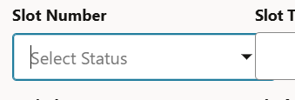
<oj-label-value class="whCodeLv">
<oj-c-select-multiple placeholder="Select Status" slot="value" data="[[ $variables.slotNumberLovADP ]]"
item-text="slot_number" id="whCode" class="whCodeSelect oj-flex-bar-end statusLabel" label-edge="top"
label-hint="Slot Number" value="{{ $variables.selectedSlotnumber }}"
on-value-changed="[[$listeners.whCodeValue]]">
</oj-c-select-multiple>
</oj-label-value>
step 2:
create an adp and map it to the data and call the rest in the event listner and assign the adp data to it .
step 3:
const response4 = await Actions.callRest(context, {
endpoint: 'ordsService/getGetslotnumberlov',
});

$variables.slotNumberLovADP.data = response4.body.items;
$variables.selectedSlotnumber = new Set([]); --- need to add in event listener by creating a new variable
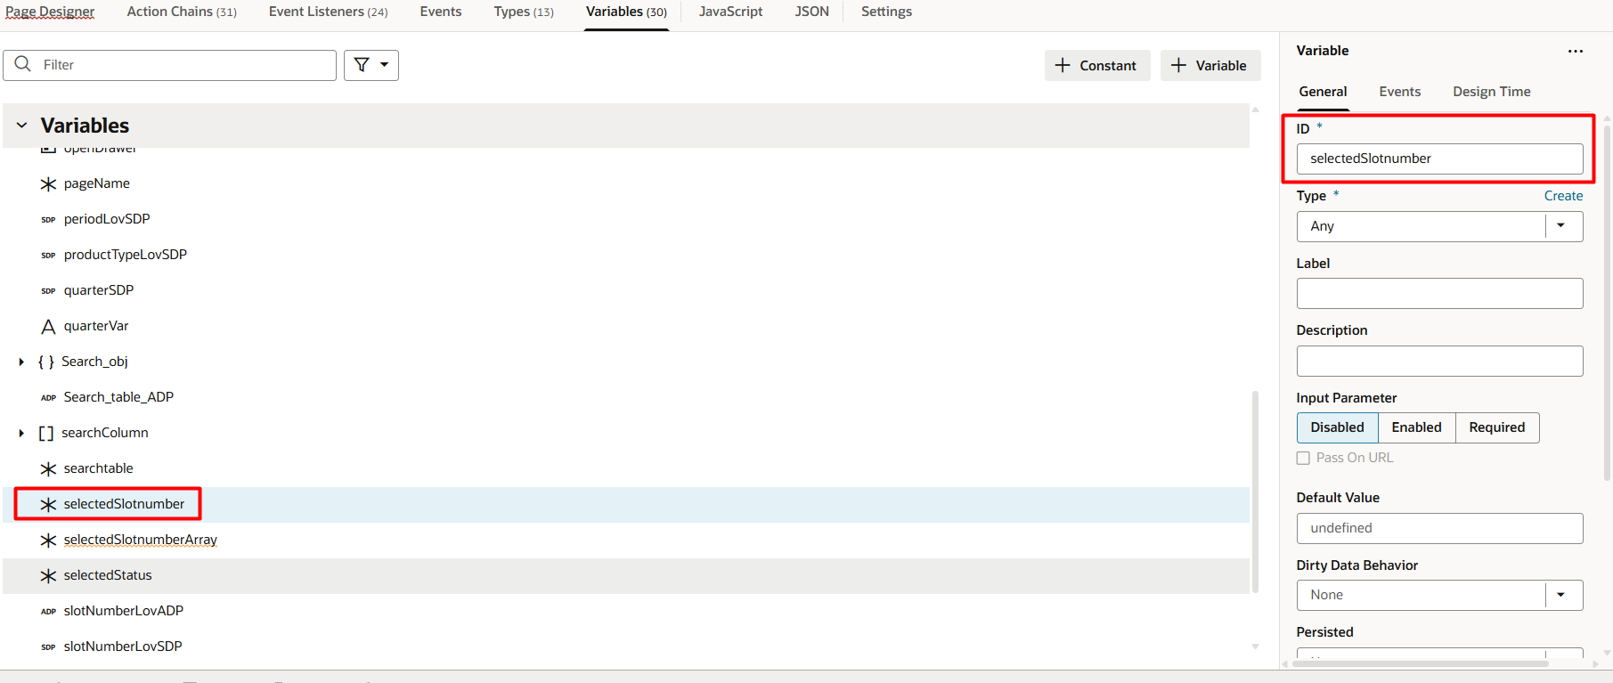
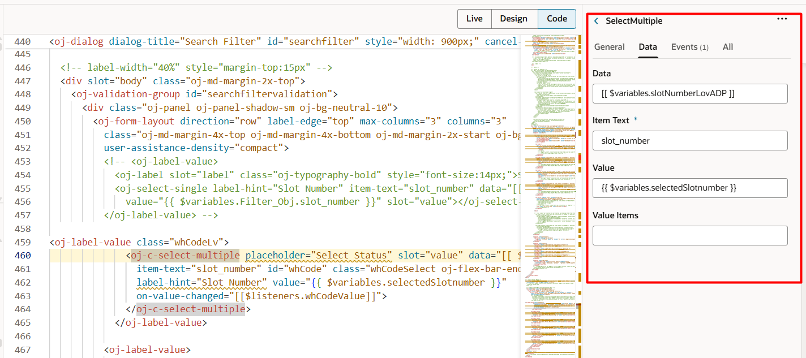
add the value chain event for the select multiple
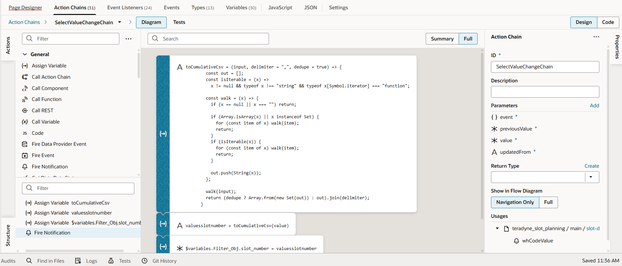
action chain code:
define([
'vb/action/actionChain',
'vb/action/actions',
'vb/action/actionUtils',
], (
ActionChain,
Actions,
ActionUtils
) => {
'use strict';

class SelectValueChangeChain extends ActionChain {

/**
* @param {Object} context
* @param {Object} params
* @param {object} params.event
* @param {any} params.previousValue
* @param {any} params.value
* @param {string} params.updatedFrom
*/
async run(context, { event, previousValue, value, updatedFrom }) {
const { $page, $flow, $application, $constants, $variables } = context;

const toCumulativeCsv = (input, delimiter = ",", dedupe = true) => {
const out = [];
const isIterable = (x) =>
x != null && typeof x !== "string" && typeof x[Symbol.iterator] === "function";

const walk = (x) => {
if (x == null || x === "") return;

if (Array.isArray(x) || x instanceof Set) {
for (const item of x) walk(item);
return;
}
if (isIterable(x)) {
for (const item of x) walk(item);
return;
}

out.push(String(x));
};

walk(input);
return (dedupe ? Array.from(new Set(out)) : out).join(delimiter);
}

const valuesslotnumber = toCumulativeCsv(value);

$variables.Filter_Obj.slot_number = valuesslotnumber;

await Actions.fireNotificationEvent(context, {
summary: $variables.Filter_Obj.slot_number,
});

}
}

return SelectValueChangeChain;
});

